**UNIVERSIDAD TECNOLÓGICA DE QUERÉTARO**

**CESEQ**



**Diplomado en Software Embebido**

Proyecto Integrador: Control de velocidad de motor CD

11.3. ThroughputRAMFlash_procedure

DOCUMENT: Software Development

Document No. #CESEQ_SDP_11.3

Scrum Master: Guarneros, Héctor

Developer. Govea, Francisco

Date (YYYYMMDD): 20190809

Version: 1.0.1.

Project Version: x.x.x.

## Log

Document Version

|  |  |  |  |
| --- | --- | --- | --- |
| Version | Date (yyyymmdd) | Description | Reviewer |
| 1.0.0. | 20190405 | First release | Pérez, Adbeel |
|  |  |  |  |

Project Document Version

|  |  |  |  |
| --- | --- | --- | --- |
| Version | Date (yyyymmdd) | Description | Reviewer |
| 1.0.0 | 20190809 | File creation | Guarneros, Héctor |
| 1.0.1 | 20190809 | Added Size Memory Usage | Guarneros, Héctor |

## *Memory Region Usage*

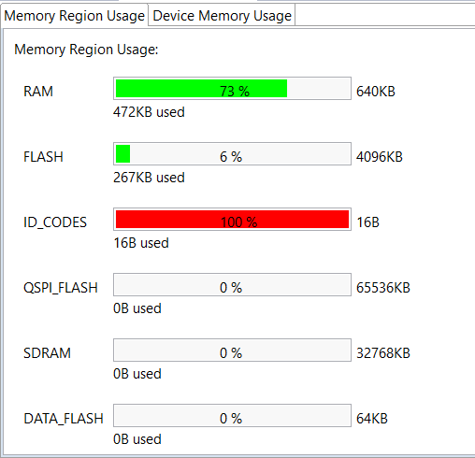

## *Memory Usage Units Size*

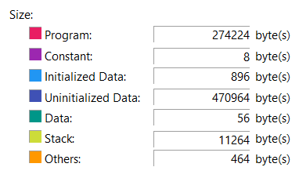

## *Memory Section Usage*

